**Day 10: Azure Synapse Analytics**

**Serverless sql pool in Azure Synapse Analytics**

Every Azure Synapse Analytics workspace comes with serverless SQL pool endpoints that you can use to query data in the [Azure Data Lake](https://learn.microsoft.com/en-us/azure/synapse-analytics/sql/query-data-storage) ([Parquet](https://learn.microsoft.com/en-us/azure/synapse-analytics/sql/query-data-storage#query-parquet-files), [Delta Lake](https://learn.microsoft.com/en-us/azure/synapse-analytics/sql/query-delta-lake-format), [delimited text](https://learn.microsoft.com/en-us/azure/synapse-analytics/sql/query-data-storage#query-csv-files) formats), [Azure Cosmos DB](https://learn.microsoft.com/en-us/azure/synapse-analytics/sql/query-cosmos-db-analytical-store?toc=/azure/synapse-analytics/toc.json&bc=/azure/synapse-analytics/breadcrumb/toc.json&tabs=openrowset-key), or Dataverse.

Serverless SQL pool is a query service over the data in your data lake. It enables you to access your data through the following functionalities:

* A familiar [T-SQL syntax](https://learn.microsoft.com/en-us/azure/synapse-analytics/sql/overview-features) to query data in place without the need to copy or load data into a specialized store. To learn more, see the [T-SQL support](https://learn.microsoft.com/en-us/azure/synapse-analytics/sql/on-demand-workspace-overview#t-sql-support) section.
* Integrated connectivity via the T-SQL interface that offers a wide range of business intelligence and ad-hoc querying tools, including the most popular drivers. To learn more, see the [Client tools](https://learn.microsoft.com/en-us/azure/synapse-analytics/sql/on-demand-workspace-overview#client-tools) section

Ideal for either structured/unstructured data.

**Dedicated sql pool in Azure Synapse Analytics**

Dedicated SQL pool (formerly SQL DW) refers to the enterprise **data warehousing features that are available in Azure Synapse Analytics**.

Data is stored in relational tables. Require dedicated servers before performing any operation.

Dedicated SQL pool (formerly SQL DW) represents a collection of analytic resources that are provisioned when using Synapse SQL. The size of a dedicated SQL pool (formerly SQL DW) is determined by Data Warehousing Units (DWU).

DIFFERENCES:

While serverless does not store data, only access data from storage accounts and scale the MPP environment automatically, the dedicate SQL Pool keeps a static number of servers according to the service level we choose and a constant number of distributions- always 60.

* Created a Synapse Analytics Workspace.

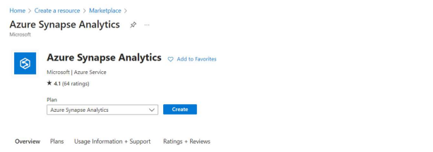

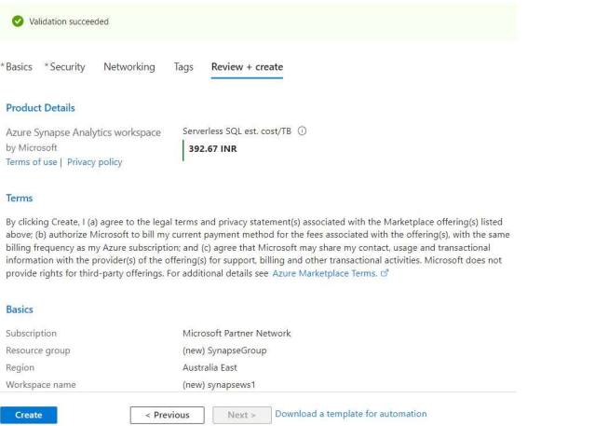

* Created a dedicated SQL Pool

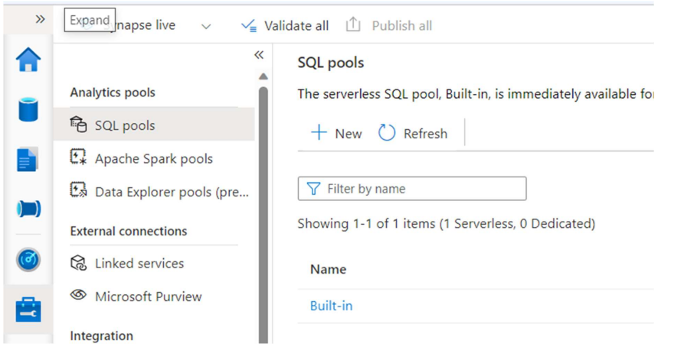

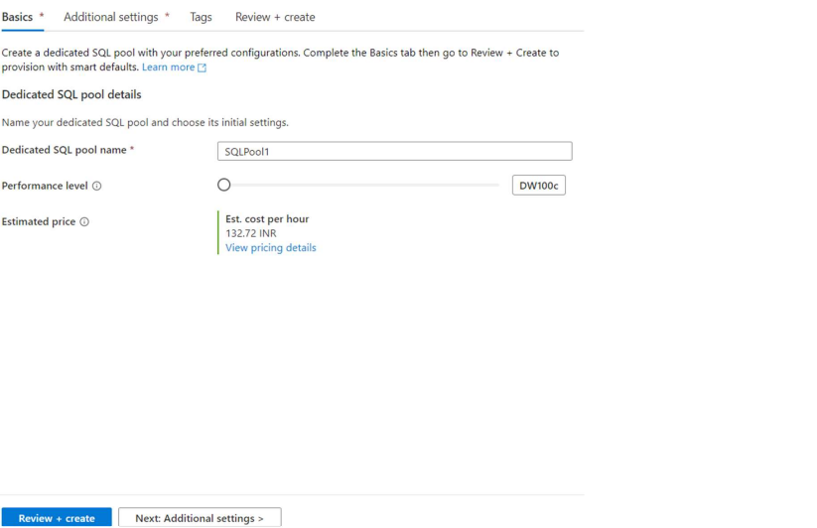

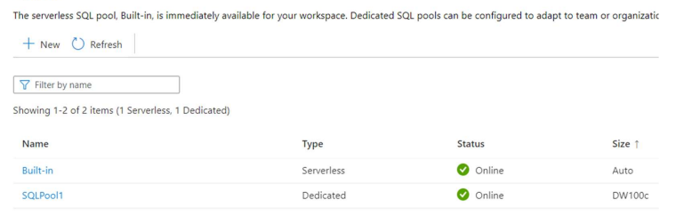

* Uploaded a parquet file in the pool.

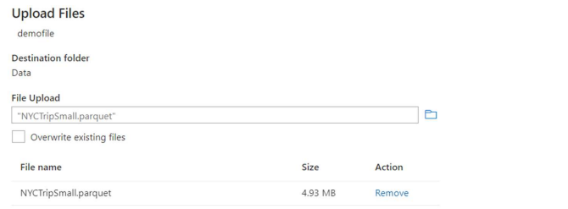

* To read the parquet file, we run the following code in the SQL script on synapse by replacing the highlighted link with : <https://rdblsynapse.dfs.core.windows.net/rdblsynapse/NYCTripSmall.parquet>

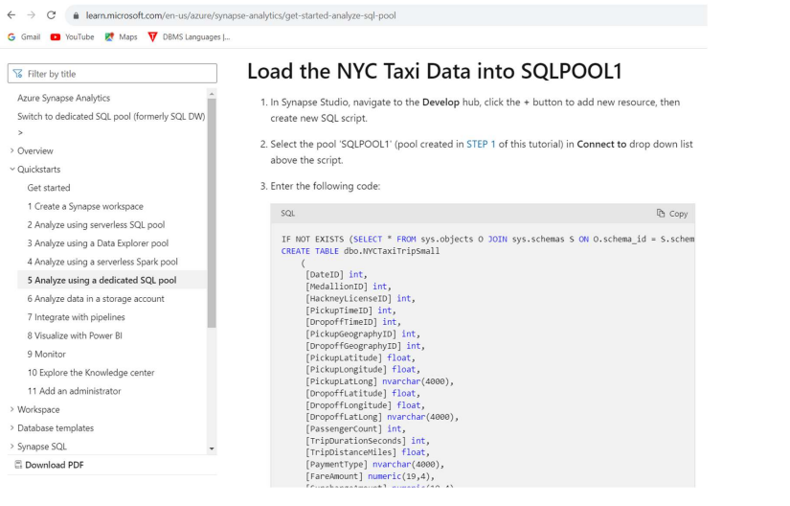

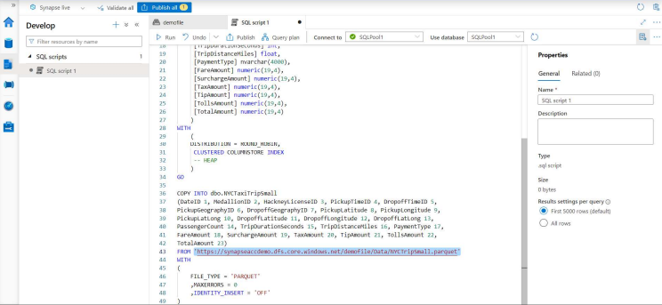

* The data is visible in the table:

